Introduction to Bootstrap 5
Bootstrap 5 is a free, open-source front-end CSS framework used to create responsive and mobile-first websites quickly. It provides pre-designed CSS classes, JavaScript components, and a responsive grid system that help developers build attractive web pages with less code.

Features of Bootstrap 5
- Responsive, mobile-first design
- Easy-to-use grid system
- Pre-built UI components (buttons, cards, forms, navbar, alerts, etc.)
- Customizable with CSS variables and Sass
- No dependency on jQuery (Bootstrap 5 uses vanilla JavaScript)
- Cross-browser compatibility

Advantages
- Faster web development
- Consistent design across pages
- Easy responsiveness for different screen sizes
- Large community support and documentation

simple bootstrap example
<!DOCTYPE html>
<html lang="en">
<head>
<meta charset="UTF-8">
<meta name="viewport" content="width=device-width, initial-scale=1.0">
<title>Basic Bootstrap Program</title>

<!-- Bootstrap CSS -->
<link href="https://cdn.jsdelivr.net/npm/bootstrap@5.3.0/dist/css/bootstrap.min.css" rel="stylesheet">
</head>

<body>

<div class="container mt-5">
<h1 class="text-primary">Hello Bootstrap!</h1>
<p class="lead">This is a basic Bootstrap webpage.</p>

<button class="btn btn-success">
Click Me
</button>
</div>

<!-- Bootstrap JavaScript -->
<script src="https://cdn.jsdelivr.net/npm/bootstrap@5.3.0/dist/js/bootstrap.bundle.min.js"></script>

</body>
</html>

OUTPUT:
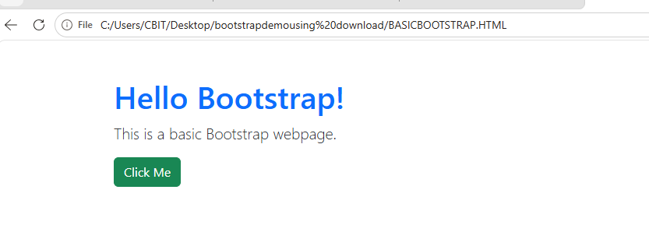

<!DOCTYPE html>
<html>
<head>
<title>Simple Bootstrap Example</title>

<!-- Bootstrap 5 CSS -->
<link href="https://cdn.jsdelivr.net/npm/bootstrap@5.3.3/dist/css/bootstrap.min.css" rel="stylesheet">
</head>
<body>

<div class="container mt-5">

<h1 class="text-primary">Welcome to Bootstrap</h1>

<p class="lead">
Bootstrap makes web pages responsive and attractive.
</p>

<button class="btn btn-success">
Click Me
</button>

<div class="alert alert-warning mt-3">
This is a Bootstrap alert message.
</div>

</div>

</body>
</html>
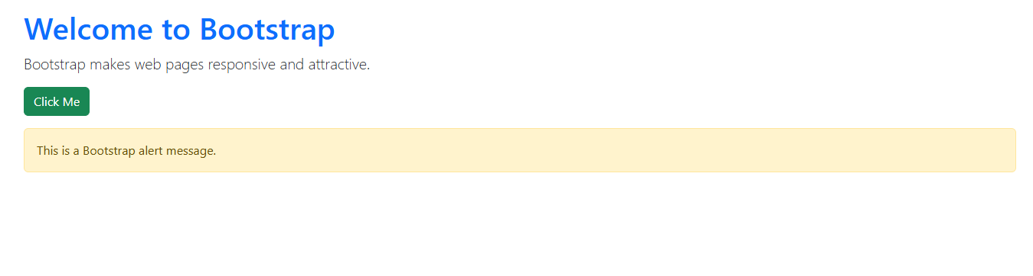

BOOTSRAP EXAMPLE FOR DISPLAYING MESSAGE AFTER CLICK BUTTON

<!DOCTYPE html>
<html>
<head>
<title>Simple Bootstrap Example</title>

<!-- Bootstrap 5 CSS -->
<link href="https://cdn.jsdelivr.net/npm/bootstrap@5.3.3/dist/css/bootstrap.min.css" rel="stylesheet">
</head>

<body>

<div class="container mt-5">

<h1 class="text-primary">Welcome to Bootstrap</h1>

<p class="lead">
Bootstrap makes web pages responsive and attractive.
</p>

<button class="btn btn-success" onclick="showAlert()">
Click Me
</button>

<!-- Alert message (hidden initially) -->
<div id="message" class="alert alert-warning mt-3" style="display:none;">
This is a Bootstrap alert message.
</div>

</div>

<script>
function showAlert() {
document.getElementById("message").style.display = "block";
}
</script>

</body>
</html>

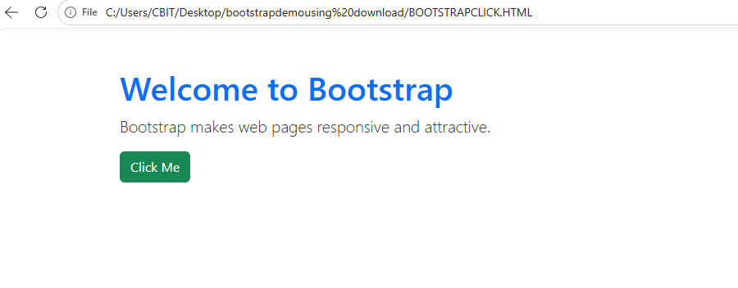
WITH THE HELP OF JAVACSRIPT CLICK ON “CLICK ME “ IT DISPLAYS ALERT MESSAGE

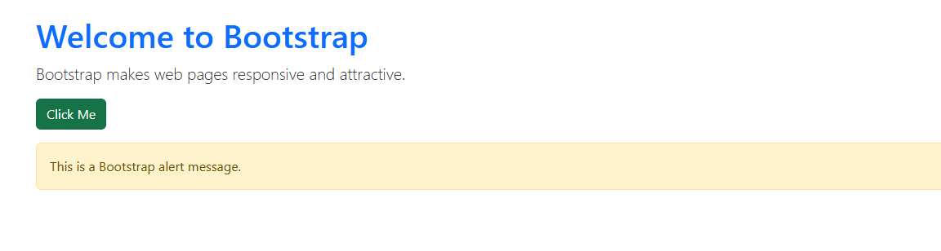

container → Creates a responsive content area with proper spacing.
mt-5 → Adds margin at the top.
text-primary → Displays the heading in blue.
lead → Makes the paragraph slightly larger.
btn btn-success → Creates a green Bootstrap button.
alert alert-warning → Displays a yellow warning alert.

<!DOCTYPE html>
- Declares that the document is an HTML5 document.
<html>
- The root element of the HTML page.
- All HTML code is written inside this tag.
<head>
- Contains information about the webpage, such as the title and external files.
- This content is not displayed on the webpage.

<title>Simple Bootstrap Example</title>
- Sets the title of the webpage.
- This title appears on the browser tab.

<link href="https://cdn.jsdelivr.net/npm/bootstrap@5.3.3/dist/css/bootstrap.min.css" rel="stylesheet">
- Loads the Bootstrap 5 CSS file from a CDN (Content Delivery Network).
- Without this line, Bootstrap classes such as btn, container, and alert will not work.

https://cdn.jsdelivr.net/npm/bootstrap@5.3.3/dist/css/bootstrap.min.css" rel="stylesheet

<link href="https://cdn.jsdelivr.net/npm/bootstrap@5.3.3/dist/css/bootstrap.min.css" rel="stylesheet">
It tells the browser to download and use the Bootstrap CSS file from the internet.
<link>
- The <link> tag is used to connect an external file to your HTML page.
- In this case, it connects the Bootstrap CSS stylesheet.

href
href="..."
- href stands for Hypertext Reference.
- It specifies the location (URL) of the file to load.
Here,
href="https://cdn.jsdelivr.net/npm/bootstrap@5.3.3/dist/css/bootstrap.min.css"
means:
"Download the Bootstrap CSS file from this web address."

https://
https://
- https stands for HyperText Transfer Protocol Secure.
- It is a secure method for downloading files from the internet.
- The data is encrypted while being transferred.
cdn.jsdelivr.net
cdn.jsdelivr.net
This is the website (server) that stores Bootstrap files.
CDN stands for Content Delivery Network.

What is a CDN?
A CDN is a network of servers located around the world.
Instead of downloading Bootstrap from a single computer, your browser downloads it from the nearest server, making it:
- Faster
- More reliable
- Less load on the original website
Example:
If you're in India, the Bootstrap file may be served from a nearby server in Asia instead of one in the United States.

bootstrap
bootstrap
This is the name of the library you're downloading.
Bootstrap contains ready-made CSS classes such as:
- Buttons
- Forms
- Navigation bars
- Cards
- Alerts
- Grid system
- Responsive layouts

@5.3.3
@5.3.3
This specifies the Bootstrap version.
Here:
- Major version = 5
- Minor version = 3
- Patch version = 3
Using a version number ensures your project uses a consistent release.

dist
dist
dist stands for Distribution.
This folder contains the files that are ready to use in a website.
Think of it as the final packaged version of Bootstrap.
css
css
This folder contains Bootstrap's CSS files.
CSS (Cascading Style Sheets) controls how HTML elements look, including colors, fonts, spacing, and layouts.

bootstrap.min.css
bootstrap.min.css
Let's split it further.

bootstrap
The stylesheet belongs to the Bootstrap framework.

.css
Indicates that it's a CSS file.

.min
min means minified.
A minified file has:
- Removed spaces
- Removed comments
- Removed unnecessary line breaks
For example:
Normal CSS
h1 {
color: blue;
font-size: 30px;
}
Minified CSS
h1{color:blue;font-size:30px;}
Both work the same, but the minified version is smaller and downloads faster.

rel="stylesheet"
rel="stylesheet"
rel stands for relationship.
It tells the browser what kind of file is being linked.
Here,
rel="stylesheet"
means:
"The linked file is a CSS stylesheet."
Without this, the browser wouldn't know how to use the linked file.

How it works
When the browser reads:
<link href="https://cdn.jsdelivr.net/npm/bootstrap@5.3.3/dist/css/bootstrap.min.css" rel="stylesheet">
it performs these steps:
- Opens the URL.
- Downloads the Bootstrap CSS file.
- Reads all the Bootstrap style rules.
- Applies those styles to any HTML elements using Bootstrap classes.
For example:
<button class="btn btn-primary">Click Me</button>
Without the <link> tag, the button appears as a plain HTML button.
With the <link> tag, Bootstrap styles it as a blue, modern-looking button.

Summary Table
Part | Meaning
<link> | Connects an external file to the HTML page
href | Specifies the location of the file
https:// | Secure protocol for downloading files
cdn.jsdelivr.net | CDN server hosting Bootstrap files
bootstrap | The Bootstrap framework
@5.3.3 | Bootstrap version 5.3.3
dist | Distribution folder containing ready-to-use files
css | Folder containing CSS files
bootstrap.min.css | Minified Bootstrap CSS stylesheet
rel="stylesheet" | Tells the browser the linked file is a CSS stylesheet

In simple words
"Go to the jsDelivr server, download the Bootstrap 5.3.3 CSS file, and use it to style this webpage."
Without this line, Bootstrap classes such as container, btn, alert, card, and navbar will have no effect because the browser won't know their styling rules.
what is patch version
A patch version is the third number in a software version, and it is used for small updates or bug fixes that do not add major new features or break existing code.
For example, in the Bootstrap version:
5.3.3
│ │ │
│ │ └── Patch Version
│ └──── Minor Version
└────── Major Version

Version Number Format
Software versions usually follow this pattern:
Major.Minor.Patch
For example:
- 5.3.0
- 5.3.1
- 5.3.2
- 5.3.3
Here:
- 5 → Major version
- 3 → Minor version
- 3 → Patch version

What does a Patch Version include?
A patch version is released to:
- Fix bugs or errors.
- Improve performance.
- Fix security vulnerabilities.
- Make small improvements without changing how the software is used.
It does not usually introduce new features or require changes to your existing code.

Example
Suppose Bootstrap 5.3.2 has a button alignment bug.
The developers fix the bug and release:
Bootstrap 5.3.3
The only change is the bug fix. Your existing Bootstrap code will continue to work.

Difference Between Major, Minor, and Patch Versions
Version Type | Example | Purpose
Major | 4.0.0 → 5.0.0 | Large changes, new features, possible breaking changes
Minor | 5.2.0 → 5.3.0 | Adds new features while remaining compatible
Patch | 5.3.2 → 5.3.3 | Fixes bugs, improves security, and optimizes performance

Real-World Analogy
Think of a mobile app:
- Major version (1 → 2): The app gets a completely new design and many new features.
- Minor version (2.1 → 2.2): A few new features are added, like dark mode or a new settings page.
- Patch version (2.2.0 → 2.2.1): A crash is fixed, loading becomes faster, or a security issue is resolved.

In Bootstrap
When you use:
<link href="https://cdn.jsdelivr.net/npm/bootstrap@5.3.3/dist/css/bootstrap.min.css" rel="stylesheet">
5.3.3 means:
- 5 → Bootstrap 5 (major release)
- 3 → Third minor update
- 3 → Third patch release for version 5.3, containing bug fixes and small improvements.
Get smarter responses, upload files and images, and more.

</head>
- Ends the head section.
<body>
- Starts the body section.
- Everything inside the <body> is displayed in the browser.
<div class="container mt-5">
- Creates a Bootstrap container.
- container gives the content a responsive width and proper spacing.
- mt-5 means Margin Top = 5, adding space above the container.

<h1 class="text-primary">Welcome to Bootstrap</h1>
- Displays a large heading.
- text-primary changes the text color to blue (Bootstrap's primary color).
Output:
Welcome to Bootstrap
(Displayed in blue.)

<p class="lead">
Bootstrap makes web pages responsive and attractive.
</p>
- Creates a paragraph.
- lead makes the paragraph larger and more prominent than normal text.
Output:
Bootstrap makes web pages responsive and attractive
<button class="btn btn-success">
Click Me
</button>
- Creates a button.
- btn applies Bootstrap button styling.
- btn-success makes the button green.
Output:
[ Click Me ]
(A green button.)

<div class="alert alert-warning mt-3">
This is a Bootstrap alert message.
</div>
- Creates an alert (message box).
- alert applies alert styling.
- alert-warning gives it a yellow warning appearance.
- mt-3 adds margin above the alert.
Output:
⚠ This is a Bootstrap alert message.
(Yellow background with Bootstrap warning style.)
</div>
- Close the container.
</body>
- Ends the body section.
</html>
- Ends the HTML document.

Final Output
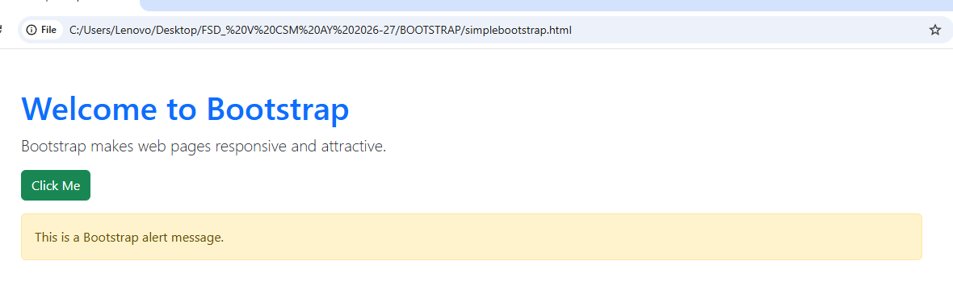

Bootstrap Classes Used
Class | Purpose
container | Creates a responsive content area with proper spacing
mt-5 | Adds top margin (large spacing)
text-primary | Changes text color to blue
lead | Makes paragraph text larger and more noticeable
btn | Applies Bootstrap button styling
btn-success | Makes the button green
alert | Creates an alert/message box
alert-warning | Gives the alert a yellow warning style
mt-3 | Adds a small top margin above the alert

Here's a very simple Bootstrap 5 example that demonstrates the use of .container and .container-fluid.

Example 1: Using .container
<!DOCTYPE html>
<html>
<head>
<title>Bootstrap Container</title>

<!-- Bootstrap CSS -->
<link href="https://cdn.jsdelivr.net/npm/bootstrap@5.3.3/dist/css/bootstrap.min.css" rel="stylesheet">
</head>
<body>

<div class="container bg-light border p-4 mt-4">
<h2>Welcome to Bootstrap</h2>
<p>This content is inside a <strong>container</strong>.</p>
</div>

</body>
</html>
Output:
- The content appears in the center of the page.
- There is space (margin) on the left and right sides.
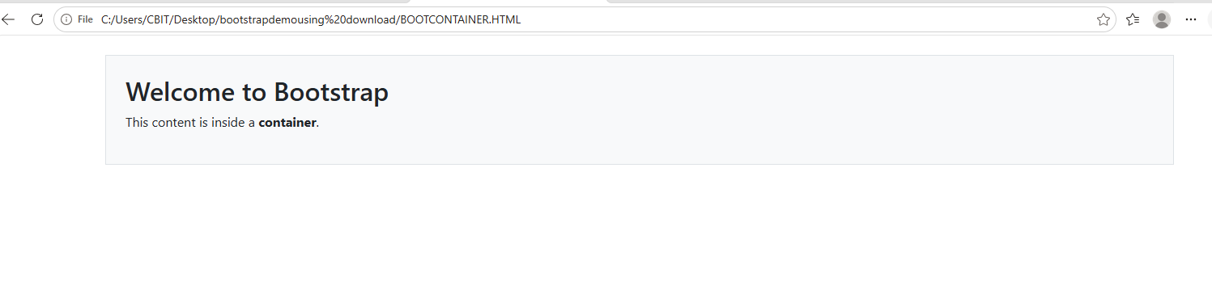

Example 2: Using .container-fluid
<!DOCTYPE html>
<html>
<head>
<title>Bootstrap Container Fluid</title>

<!-- Bootstrap CSS -->
<link href="https://cdn.jsdelivr.net/npm/bootstrap@5.3.3/dist/css/bootstrap.min.css" rel="stylesheet">
</head>
<body>

<div class="container-fluid bg-primary text-white p-4">
<h2>Welcome to Bootstrap</h2>
<p>This content is inside a <strong>container-fluid</strong>.</p>
</div>

</body>
</html>
Output:
- The blue background stretches across the entire width of the browser.
- The content fills the full page width.
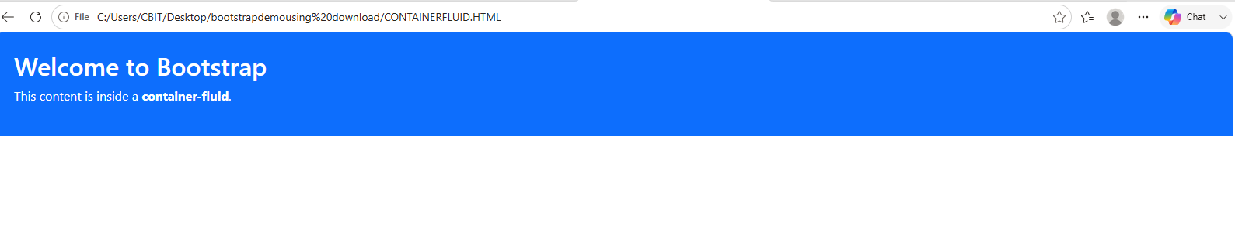

Example 3: Compare Both on the Same Page
<!DOCTYPE html>
<html>
<head>
<title>Bootstrap Demo</title>

<!-- Bootstrap CSS -->
<link href="https://cdn.jsdelivr.net/npm/bootstrap@5.3.3/dist/css/bootstrap.min.css" rel="stylesheet">
</head>
<body>

<!-- Fixed-width container -->
<div class="container bg-warning p-3 mt-3">
<h3>Container</h3>
<p>This box has margins on both sides.</p>
</div>

<!-- Full-width container -->
<div class="container-fluid bg-success text-white p-3 mt-3">
<h3>Container Fluid</h3>
<p>This box stretches across the entire screen.</p>
</div>

</body>
</html>

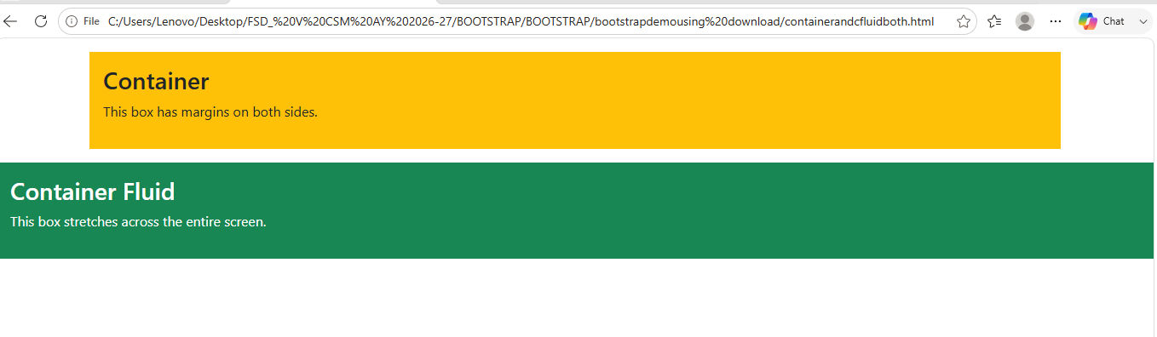Key Difference
.container | .container-fluid
Fixed responsive width | 100% width of the screen
Leaves margins on left and right | No side margins
Best for normal web pages | Best for banners, headers, and full-width sections
This simple comparison clearly demonstrates the difference between the two Bootstrap container classes.
simple bootstrap example
Here is a very simple Bootstrap 5 example that demonstrates some common Bootstrap classes such as container, btn, and alert.

Bootstrap Classes
A class in Bootstrap is a predefined CSS style that you apply to HTML elements using the class attribute. Bootstrap classes help you create attractive and responsive web pages without writing your own CSS.

Syntax
<tag class="bootstrap-class">Content</tag>

Common Bootstrap Classes
Class | Purpose
container | Creates a responsive container
text-primary | Changes text color to blue
text-danger | Changes text color to red
bg-success | Gives a green background
btn | Styles an element as a button
btn-primary | Creates a blue button
alert | Creates an alert box
alert-warning | Creates a yellow warning alert
p-3 | Adds padding
mt-3 | Adds top margin

Example of Bootstrap Classes
<!DOCTYPE html>
<html>
<head>
<title>Bootstrap Classes</title>

<link href="https://cdn.jsdelivr.net/npm/bootstrap@5.3.3/dist/css/bootstrap.min.css" rel="stylesheet">
</head>
<body>

<div class="container mt-4">

<h2 class="text-primary">Bootstrap Classes</h2>

<p class="text-success">
This text is green.
</p>

<button class="btn btn-primary">
Submit
</button>

<div class="alert alert-warning mt-3">
This is a warning message.
</div>

</div>

</body>
</html>

Output
- Blue heading
- Green paragraph
- Blue button
- Yellow alert box

Bootstrap Grid System
The Bootstrap Grid System is a layout system that divides a webpage into 12 equal columns.
It helps you arrange content into rows and columns, making your webpage responsive on different screen sizes.

Grid Structure
Container
│
└── Row
│
├── Column
├── Column
└── Column
A Bootstrap grid always follows this order:
- Container
- Row
- Column

12-Column Layout
|1|2|3|4|5|6|7|8|9|10|11|12|
The total width of a row is 12 columns.
Examples:
- col-6 + col-6 = 12
- col-4 + col-4 + col-4 = 12
- col-3 + col-3 + col-3 + col-3 = 12

Example 1: Two Equal Columns
<!DOCTYPE html>
<html>
<head>
<title>Bootstrap Grid Example</title>

<link href="https://cdn.jsdelivr.net/npm/bootstrap@5.3.3/dist/css/bootstrap.min.css" rel="stylesheet">
</head>
<body>

<div class="container mt-4">

<div class="row">

<div class="col-6 bg-primary text-white p-3">
Left Column
</div>

<div class="col-6 bg-success text-white p-3">
Right Column
</div>

</div>

</div>

</body>
</html>

Explanation
- container → Holds the content.
- row → Creates a horizontal row.
- col-6 → Uses 6 out of 12 columns (50% width).
- Two col-6 columns together fill the entire row.
Output
+--------------------+--------------------+
| Left Column | Right Column |
+--------------------+--------------------+

Example 2: Three Equal Columns
<!DOCTYPE html>
<html>
<head>
<title>Three Columns</title>

<link href="https://cdn.jsdelivr.net/npm/bootstrap@5.3.3/dist/css/bootstrap.min.css" rel="stylesheet">
</head>
<body>

<div class="container mt-4">

<div class="row">

<div class="col-4 bg-danger text-white p-3">
Column 1
</div>

<div class="col-4 bg-warning p-3">
Column 2
</div>

<div class="col-4 bg-info p-3">
Column 3
</div>

</div>

</div>

</body>
</html>

Explanation
- Each col-4 occupies 4 columns.
- 4 + 4 + 4 = 12.
- Therefore, the three columns fit perfectly in one row.
Output
+------------+------------+------------+
| Column 1 | Column 2 | Column 3 |
+------------+------------+------------+

Example 3: Four Equal Columns
<div class="container">
<div class="row">

<div class="col-3 bg-primary text-white p-3">1</div>
<div class="col-3 bg-success text-white p-3">2</div>
<div class="col-3 bg-warning p-3">3</div>
<div class="col-3 bg-danger text-white p-3">4</div>

</div>
</div>
Since 3 + 3 + 3 + 3 = 12, all four columns appear in a single row.

Responsive Grid Example
Bootstrap also provides responsive column classes.
<div class="container">
<div class="row">

<div class="col-md-6 bg-primary text-white p-3">
Left
</div>

<div class="col-md-6 bg-success text-white p-3">
Right
</div>

</div>
</div>

How it works
- col-md-6 means:
  - On medium (md) and larger screens, each column takes 6 columns (50% width).
  - On small screens (mobile), each column automatically takes the full width and appears one below the other.

Summary
Bootstrap Class | Purpose
container | Creates a responsive container
row | Creates a horizontal row
col-6 | Uses 6 out of 12 columns (50% width)
col-4 | Uses 4 out of 12 columns (33.33% width)
col-3 | Uses 3 out of 12 columns (25% width)
btn | Styles an element as a button
alert | Creates an alert box
text-primary | Changes text color to blue
bg-success | Gives a green background

Key Points
- Bootstrap provides predefined classes that style HTML elements.
- The grid system divides a row into 12 columns.
- Always follow the structure: container → row → column.
- Use column classes like col-6, col-4, or col-md-6 to control how much space each element occupies and to create responsive layouts.

